Biosphere Guided Notes
- Biosphere- , living things are affected by the interactions between nonliving ( ) and other living ( ) things
Abiotic | Biotic

- - is the study of interactions that occur between organisms and their environment

- Ecology Levels Organization-
- Organisms > > > >

>

- Population- group of organisms of same species that and live in the same area at the same time; for same resources.
  - EX:

- Community- made up of in a certain area at a certain time
  - EX:

- Ecosystem- interacting populations in a community and the community’s factors
  - EX:

- Koppen Climate Classification- In 1884 Russian German climatologist Wladimir Köppen was first to organize the world into climate classifications based on and
.
- Tropical-
- Desert-
- Temperate-
- Taiga-
E.) Tundra-
Biomes- made of similar ecosystems and are controlled by .
  - Climate determines what plants will grow there, and what animals will inhabit it.
  - All three components- , and are interwoven to create a biome.

- Biodiversity- variation within populations and variation of populations within ecosystems; the variety of species in one area.
- The greater the biodiversity within an area, the greater the available to support the ecosystems.
- Simplest measure of biodiversity is the number of different species that live in a certain area
- EX: 1 hectare of US contains about 30 different tree species VS 1 hectare of Amazon rainforest that contains 300 species of trees
- Which has the greatest biodiversity?

Why is biodiversity important?
- All living things are -any given species depends on the services of another species to survive.
- Limits chances of a species extinction- in a population prevents one pest or disease from completely wiping out the population.
- Variety of organisms help to maintain an ecosystem-organisms collectively can contribute to soil formation, pollution breakdown, nutrient storage, or contribute to .
- Greater biodiversity provides larger pool of resources-more organisms we can use for food, purposes, wood products, animals for breeding stocks, etc.
Threats to Biodiversity
- Human Population Growth
- Demand for resources > amount of resources
- Birth Rate > Death Rate
- Population may surpass carrying capacity
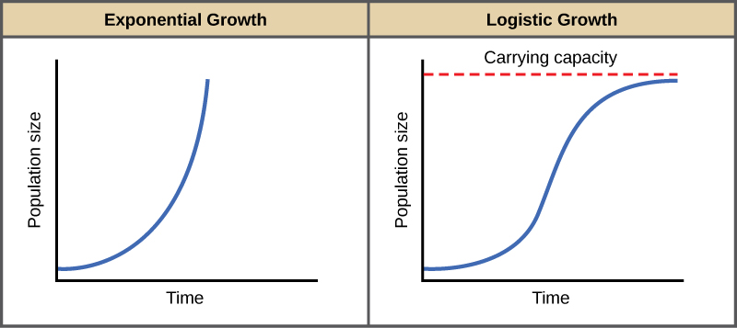

Click on the Earth. What is the current human population?

- Invasive Species
- A nonnative species whose introduction causes , ,
issues by disrupting ecosystems.
- Take resources from native species.
- introduced intentionally to US as an ornamental plant and to help reduce soil erosion. However, it grows rapidly, smothering areas of native plants.
- were introduced unintentionally to Great Lakes from ballasts of ships. These fast growing mussels the , but destroy many food chains
- Habitat Alteration
- Any change that occurs to an existing habitat.
- -removing all plants, destroying habitats
- -removing only parts of a region, causing habitat fragmentation, separating species from one another, increasing or decreasing populations as a result.
- - larger species in greater danger; large predators may not find enough food if restricted to too small an area.
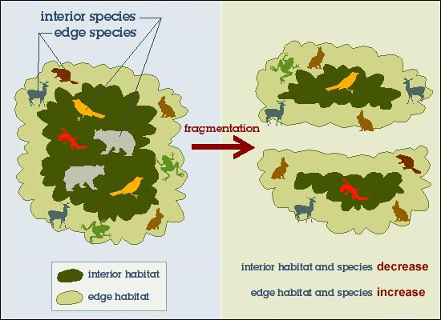

- Overharvesting
- Consuming too much of a population severely decrease their numbers, therefore causing a disruption in food chain.
- Depletes ecological resources to harmful levels that make hunting and fishing of the species unsustainable
- Keystone Species- a plant or animal that plays a unique and crucial in the way an ecosystem functions. Without keystone species, the ecosystem would dramatically change or cease to exist altogether
- EX: plant= ginseng, animal= elephant

- Pollution- Habitat Degradation
- Habitat degradation is the damage done to a habitat by pollution – , , or
.
Acid Rain
- Acid rain is any precipitation that has a pH value
- Water in atmosphere becomes acidified due to: burning factories, car , and .
- Results in damage to plant tissue and can affect aquatic species ability to
Eutrophication
- Fertilizer and animal waste are carried into hydrosphere.
- These nutrients allow to occur.
- As the algae dies and decays, it removes oxygen from the water, killing the fish and creating
.
Trash Pollution
- Trash and abandoned nets are the cause of of many aquatic animals.
- Reduce, Reuse, Recycle: Tips on reducing waste and conserving resources.
- The three R's - reduce, reuse and recycle - all help to cut down on the amount of waste we throw away.
- They conserve natural , space and .
- They save land and money must use to dispose of waste in landfills.
- Siting a new landfill has become and more due to environmental regulations and public opposition
- “ ”- the impact of human activities measured in terms of the area of biological productive and required to produce goods consumed. It is the amount of the environmental necessary to produce the and necessary to support a particular lifestyle.
What does the future hold?
- Consequences of loss of biodiversity- extinction, ecosystem collapse, possible medical cures for diseases disappear, and the unknown.
- How to Protect Biodiversity? Conservation biology, legislation designed to preserve habitats, reintroduction and captive breeding programs, and reducing “ecological footprint.”

