Cloud Formation and Air Masses Guided Notes

1. ________________________ is the temperature at which air must be cooled to reach saturation. ____________________ is the phase change from gas to liquid; it only occurs when the air reaches saturation. The __________ _______________________________ _______________ (LCL) is the point at which condensation occurs.
2. How clouds form:
Air masses of different temperatures ___________________. The less dense, _______________ air mass rises over the more dense, ___________________ air mass. As the warm air rises, it cools, and once it reaches the LCL, water vapor will condense around _______________________________ nuclei to become a cloud, if the density of condensation nuclei is great enough. Condensation nuclei are _______________________ in the air around which cloud droplets can form.

3. Draw a picture of cloud formation:

4. __________________________ occurs when cloud droplets collide and join together to form a larger droplet. When the droplet becomes too heavy to be held aloft, gravity takes over and it falls to Earth as ___________________________.
5. In ___________________________ ______________________, the air mass is forced to lift due to topography, cooling down quickly in the process, causing condensation and cloud formation.

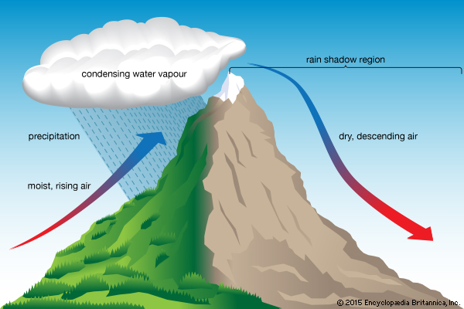

6. ______________________ is the current state of the atmosphere, while ___________________ describes the average weather over a long period of time. EX:

7. Air masses are a large body of air with similar ______________________________ and __________________________.
8. If the source of the air mass is over land the air mass will be _______________. If the sources of the air mass is over water the air mass with be _______________________.

9.
DESCRIPTION | CONDITION | LOCATION FORMED
Maritime
Continental
Tropical
Polar

10. If we combine temperature and humidity, we can create ___ types of air masses:
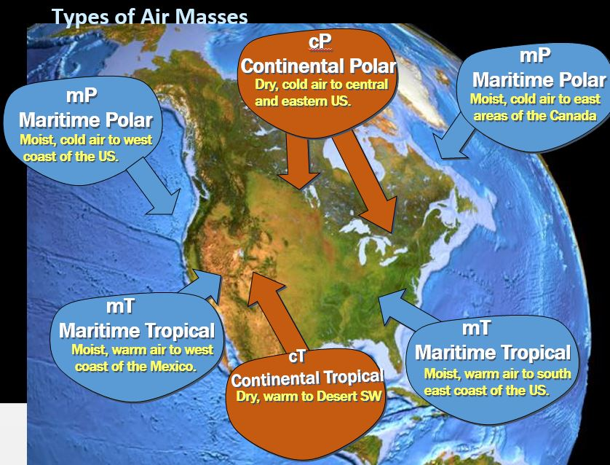
11.

12. Air masses move by prevailing _____________. The winds cause the air masses to move over ___________ and ________________. As the air masses move, they change. This is called ________________________________________. The air masses becomes more like the ___________ it is moving over… and at the same time, the area the air mass is moving over becomes more like the __________________.

