**ASTRONOMY** *Earth, Sun, and Moon Interactions* Name:

Rotation vs. Revolution

|  |  |
| --- | --- |
| Image result for toy dreidel rotation clipart | Image result for orbit clipart |

The Seasons-

|  |  |
| --- | --- |
| Summer Solstice | Winter Solstice |
| Autumnal Equinox | Vernal Equinox |

Plane of Ecliptic

Earth’s Shape

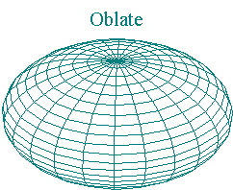

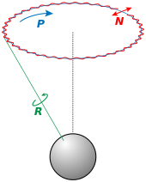Precession-

**The Moon**

Nutation –

Barycenter-

Center of Gravity-

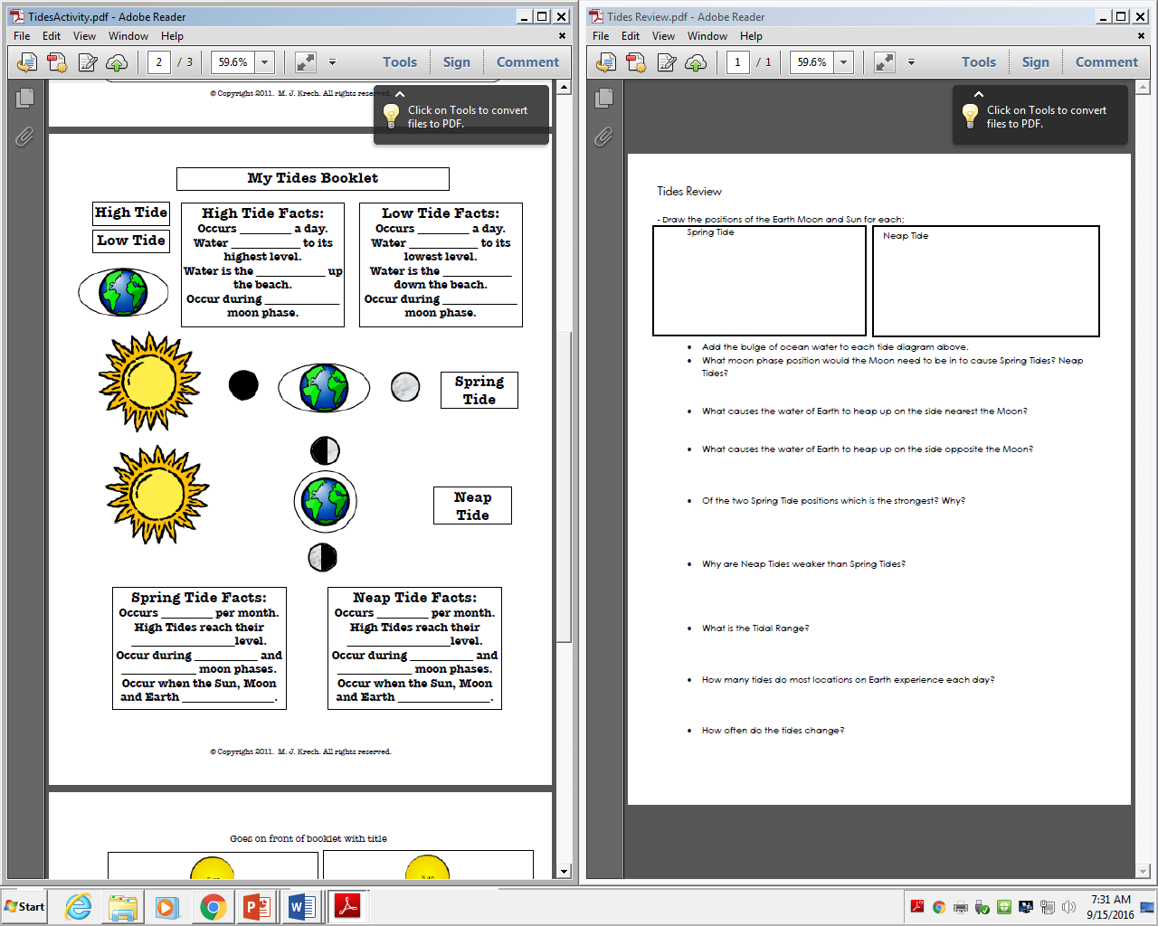

Spring Tide-

Neap Tide-