- Place the words in the correct location on the figure below: focus, epicenter, fault line, seismic waves.

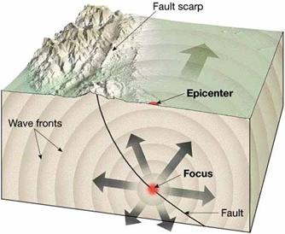

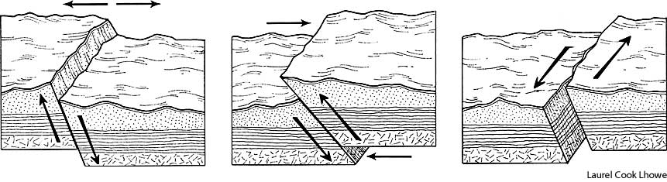
- Indicate below the type of plate boundary, the type of stress experienced, type of fault, and landforms.
______________________________ ________________________________ ____________________________
_______________________________ ________________________________ ____________________________
_______________________________ ________________________________ ____________________________

- What are each of the letters identifying in the sample seismogram below.
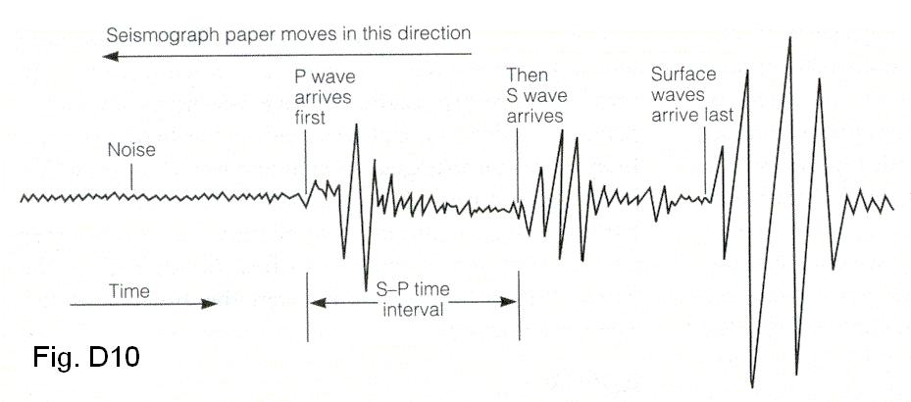
A.)
B.)
C.)
D.)

A.
E.)
B.
C.
D.

E.

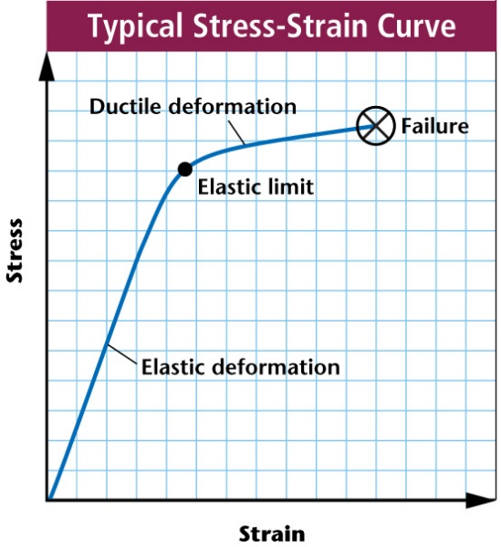
- Identify and describe each of the different parts to the
Typical Stress-Strain Curve.
B.)
D.)
C.)

A.)

- Label each picture with the type of seismic wave, the direction particles move in each, and the order in which the waves arrive after an earthquake occurs. Be sure to specify which wave does the most damage.

- What process is used by seismologists to locate the epicenter of an earthquake? How many seismometers or seismograph stations must be used? .
What is the process to determine the magnitude of an earthquake?

- Label the volcano parts below; ash cloud, lava flow, vent, crater, magma chamber, and cone

- Underline each of the following related to convergent boundaries, circle those related to divergent boundaries, and strike a line through those related to transform boundaries.
land is compressed land is pulled/stressed land strikes past each other
land is twisted subduction volcanic mountains
reverse fault trench rift zone
ocean ridge shear stress normal fault
strike slip fault tensional stress volume decreased

9.) Match each item with the correct statement below.
a. | Batholith | d. | Sill
b. | Geyser | e. | Pyroclastic flow
c. | Dike

____ 1. Mass of rock formed when a large body of magma cools inside the crust

____ 2. Formed when magma squeezes parallel to the rock it intrudes

____ 3. Rapidly moving volcanic material

____ 4. Fountain of water and steam that erupts from the ground when buildup of pressure is released

_ ___ 5. Formed when magma forces itself across rock layers and hardens

10.) Match each type of volcano with the correct illustration or description below.
a. | shield volcano | c. | composite volcano
b. | cinder-cone volcano
____ 1. Broad, gently sloping sided
____ 2. Made of layers of tephra (ash) and lava flows
____ 3. Forms from layers of basaltic lava
____ 4. Forms as tephra ejected high into the air fall back to Earth and pile around the vent
____ 5. Largest of the volcanoes
6. Island builder
7. Highest silica content and most explosive
8. Smallest of the volcanoes
9. Low silica content and most quiet

Short answer
11.) What is relationship between silica content, viscosity, and explosiveness?

12.) How does a caldera form?

13.) What is geothermal energy?

14.) What are the two different types of lava flows?
1.)
2.)
15.) Describe the 3 main types of pyroclastic material.
1.)
2.)
3.)

