Earthquakes- Seismic Activity Name:
The Focus and Epicenter of an Earthquake
- The point Earth where faulting begins is the or .

- The point directly the focus on the is the .

- Benioff Zone- is an area of increasingly deeper seismic activity, inclined from the downward in the direction of the island arc.

Where do earthquakes occur and how often?
- 80% of all earthquakes occur along the Pacific Plate known as the -
. Most of these result from margin activity
- Approximately 15% occur in the Mediterranean-Asiatic belt
- Remaining 5% occur in the of plates and on ridge centers
- More than quakes strong enough to be are recorded each year
What are seismic waves?
- Response of material to the arrival of released by a rupture or in rock
- Two Types: Body waves and Surface Waves
- Body Waves
  - P-waves or .
    - Fastest waves
    - Travel through , , or
    - Compressional wave, material movement is in the as the wave movement
  - S-waves or .
    - Slower than P-waves
    - Travel through only.
    - Shear wave- move material to wave movement.
- Surface Waves- travel just below or along the surface, slower than body waves, especially damaging to .
  - Rayleigh waves-
  - Love waves- to .
- A seismograph records earthquakes events.
- A seismogram records wave and .
  - Amplitude is the maximum height in a peak.
  - Which waves have the largest amplitude?
How is an earthquake’s epicenter located?
- Through seismic wave behavior
- P waves arrive , then S waves, later L and R
- Average speeds for all these waves is known
- After an earthquake, the difference in arrival times at a seismograph station can be used to the distance from the to the .
- Time-distance graph showing the average for P- and S-waves. The away a seismograph is from the focus of an earthquake, the the interval between the arrivals of the P- and S- waves
Triangulation: Locating an epicenter
- Three are needed to locate the epicenter of an earthquake
- A circle where the equals the to the epicenter is drawn
- The of the circles locates the
Clues to the Earth’s interior
- Seismic waves change and when they encounter different materials in Earth’s interior.
  - P-waves and S-waves traveling through the mantle follow fairly direct paths.
  - P-waves that strike the core are refracted, or , causing P-wave where no direct P-waves appear on seismograms.
  - S-waves do not enter Earth’s outer core because they cannot travel through and do not reappear beyond the P-Wave shadow zone.
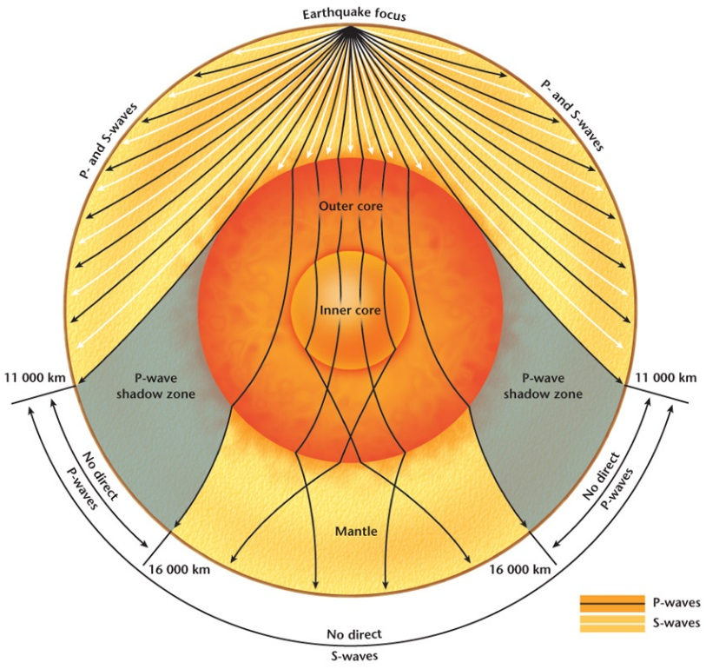
  - This disappearance of S-waves has allowed
seismologists to reason that Earth’s outer
core must be .
  - Detailed studies of how other seismic
waves reflect deep within Earth show
that Earth’s inner core is .

