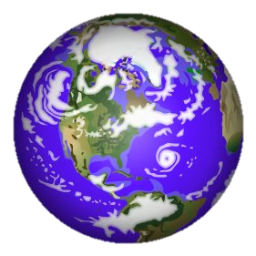
Earth’s Interior Guided Notes Name:
A. What is the Lithosphere?

B. Geologists have used two main types of evidence to learn about Earth’s interior:
- Direct evidence-
- Indirect evidence-

C. Three main layers of Earth vary greatly in…
- 3.)
- 4.)
D. THE CRUST
- Brittle, rocky outer layer of Earth
- Least dense layer
- Includes both dry land and ocean floor
Oceanic Crust
- Age:

- Color:

- Rock Composition:

- Thickness:

- Density:
Continental Crust
- Age:

- Color:

- Rock Composition:

- Thickness:

- Density:

D. THE MANTLE
1.) Layer of solid, hot rock 25 miles beneath Earth’s surface
2.) Divided into layers
a.) Lithosphere (lower part)-
b.) Asthenosphere-
c.) Lower Mantle-

3.) Mantle Convection Currents (write a detailed description)

E. THE CORE
1.) Consists mostly of the metals:
a.)
b.)
2.) Divided into two parts:
a.) Outer core-
b.) Inner Core

