Earth/Environmental Science Review Packet Name:

I. Astronomy Unit
- Day and Night (24 hrs.)
- Change in direction of the axis, but without any change in tilt- this changes which stars are above the North Pole
- Center of mass where two or more celestial bodies orbit each other (the point at which the Earth and Moon orbit as they travel around the Sun)
- A Year (365 days)
- Wobbling around the axis (occurs over an 18 year period)

- Matching. Explain the Earth’s role as a body in space.

1. Rotation
2. Revolution
3. Precession
4. Nutation
5. Barycenter

- Fill in the blanks using the terms below.
(star, galaxies, universe, satellite planet, solar systems)

The is made of which are made of many . Earth is a
belonging to one particular .
c. Circle the correct word in the parentheses after the each blank.
The universe is (expanding or contracting) after the Big Bang. This is thought to be true because the (Doppler or Coriolus) Effect shows stars that have a (red or blue) shift, indicating that they are moving away from Earth.
- True or False.
  - Kepler discovered that the path of each planet around the sun is an ellipse.
  - The universe is made of galaxies, galaxies contain stars, stars may have planetary systems.
  - Kepler’s 1st Law states that the line joining the planet to the Sun sweeps out equal areas in equal times as the planet travels around the ellipse.
  - Kepler’s 1st Law states that the orbit of the planets are ellipses, with the Sun at one focus of the ellipse.
- Fill in “tide” or “season” for the chart
Due to the approximate 23.5 degree tilt and revolution of the Earth | Due to the gravitational interaction between the Earth and the moon

- Describe Earth’s shape. .
What causes the shape of Earth?
- What is our main source of electromagnetic energy?
- True or False. Energy produced by the Sun is transferred to earth by radiation.
- Explain Nuclear Fusion.
- Explain Nuclear Fission.
- What is photosynthesis?
- Explain how the suns energy moves through the food chain.
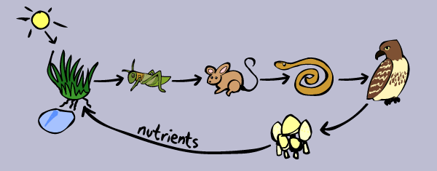
II. Lithosphere Unit
- Match each of the rock types with how they form.
- Igneous | - Melting and Cooling
- Sedimentary | - Heat and Pressure
- Metamorphic | - Weathering/Erosion and Lithification

- Explain the theory of plate tectonics using the following vocab:
- All of the following support Alfred Wegner’s Theory of Continental Drift, except .
  - The continents seemed to fit together like pieces of a puzzle.
  - There are similar fossils on different continents.
  - Mountain ranges on different continents lined up
  - Magnetic reversals at ocean ridges
- Use the word bank below to complete the sentences.
Seismograph Sea-floor spreading Earthquakes Melt
P-waves Oceanic-oceanic Trench S-waves
Epicenter Continental-continental
- New oceanic crust forms at divergent boundaries where occurs.
- An earthquakes occurs directly above the focus.
- Mountains form at convergent boundaries.
- Volcanic islands form at convergent boundaries where the more dense oceanic plate subducts under the less dense plate which also forms .
- Magma forms when rocks from the upper crust and mantle .
- A is the instrument that records earthquake waves.
- shake particles at a right angle to the direction of travel and
change a materials volume by expansion and compression.
- Predictions are made on the assumption that are repetitive (they occur on the same fault lines).
- Matching Plate Boundaries
1. Divergent Plate Boundary
2. Transform Plate Boundary
3. Convergent Plate Boundary
4. Ocean crust is created
5. Ocean crust is destroyed
6. Strike-slip Fault
7. Deep Ocean Trench
8. Crust NOT created or destroyed
9. East African Rift Valley
10. San Andreas Fault
11. Aleutian Islands
12. Mid-Atlantic Ridge

- In the chart below compare and contrast magma and lava
Magma | Lava

- Most of the active volcanoes on Earth are located in a belt known as the .
  - Ring of Lava C. East African Rift Valley
  - Ring of Fire D. Circum-Atlantic Belt

- What is the minimal number of seismic stations needed to determine the location of an Earthquake’s epicenter?
  - One C. Three
  - Two D. Four

- The particles ejected in volcanic eruptions are called .
  - Calderas C. Volcanic stocks
  - Loccoliths D. Pyroclastic material

- Which of the following factors helps determine whether a volcanic eruption will be violent or relatively quiet?
  - Amount of dissolved gases in the magma
  - Temperature of the magma
  - Composition of the magma
  - All of the above
- Geologic History of NC and the Southeastern United States. (http://www.ncpedia.org/geology)

1. Appalachian Mountains | A. line of erosion between piedmont and coastal plains
2. Fall Zone | B. due to the uplifting of rock in the western part of NC
3. Shorelines | C. area of land that contributes water to a river
4. Barrier Islands | D. affected by erosion due to increase in sea level
5. River Basins | E. built up by sediment from rivers, and constantly changing due to wave erosion.

- Earthquake Faults
- Compression Strain 6. Strike-slip Fault
- Shearing Strain 7. Forms Mountains
- Tension Strain 8. Forms Rift Valleys
- Normal Fault 9. Forms Fault Zones
- Reverse Fault 10. Hanging wall moves down

- Types of Volcanoes
- Island Builder
- Highest silica content and most explosive
- Lowest silica content and most effusive (quiet)
- Smallest of volcanoes
- Broad, gently sloping sides
- Forms from ejected tephra piled around vent
- Forms from layers of basaltic lava
- Forms from layers of tephra (ash) and lava flows
- Vent

- Layers of cinder, ash, and volcanic block
C.
- Vent

- Alternate layers of cinder, ash, and lava flow
B.
A.
- Vent

- Gentle slope of basaltic lava flow

- Human Influences on the Lithosphere- define each of the terms below and match them with one or more of the following human activities;

mining, deforestation, agriculture, overgrazing, urbanization

  - Soil Erosion-
  - Desertification-
  - Nutrient Depletion-
  - Global Warming-
  - Heat Islands-

III. Hydrosphere Unit

  - Explain how water is an energy agent.

    - Explain how warm and cold currents cycle throughout the ocean using the following terms;

density, temperature, wind, gyre, equator, north pole, and rotation

  - Explain how coastal cities are warmer than inland cities during the winter due to specific heat capacity.
  - Label the watershed with : source, estuary, floodplain, tributaries, river, oxbow lake
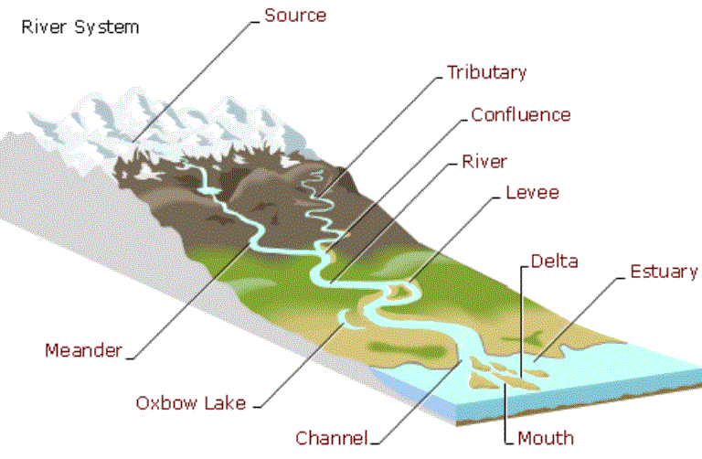

  - Label: evaporation, transpiration, precipitation, condensation, run off
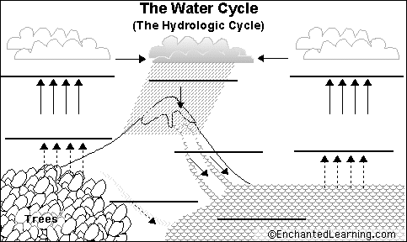

  - Evaluate human influences on freshwater availability. Fill in the blank: aquifer, dams, well, agriculture, recreation, subsidence, salt water intrusion.

To access groundwater, are dug into an . The primary use of groundwater by humans is for . Issues with aquifers include (sinking of sediment) and (contamination of salt water by the coast). Humans have altered the landscape and increased availability of freshwater through the construction of . This results in man-made reservoirs/lakes that can be used for .

  - The growing human population will (increase or decrease) freshwater as a resource.
  - True or False.
    - Pollution in the ground cannot affect freshwater
    - Pollution at one area of a watershed cannot affect other areas of the watershed
    - A biotic index of macroinvertebrates can be used to determine water quality

  - What causes upwellings and what are the benefits associated with this event?

  - What is the difference between point-source and non-point source pollution?

  - Label: confined aquifer, unconfined aquifer, water table
