Name: _____________________________ Period: _____ Date: ______________
Ground Water: Problem Worksheet
PROBLEM
You would like to build a house in a wooded area close to your school. Since city water is not available, you will need to drill a well. The well-drilling company you hired did test drillings to find a clean, accessible, and maintainable aquifer. After completing its work, the company gave you a map of four available drill sites, numbers 1, 2, 3, and 4. Use the map illustration to make your analysis. Then answer the questions that follow.

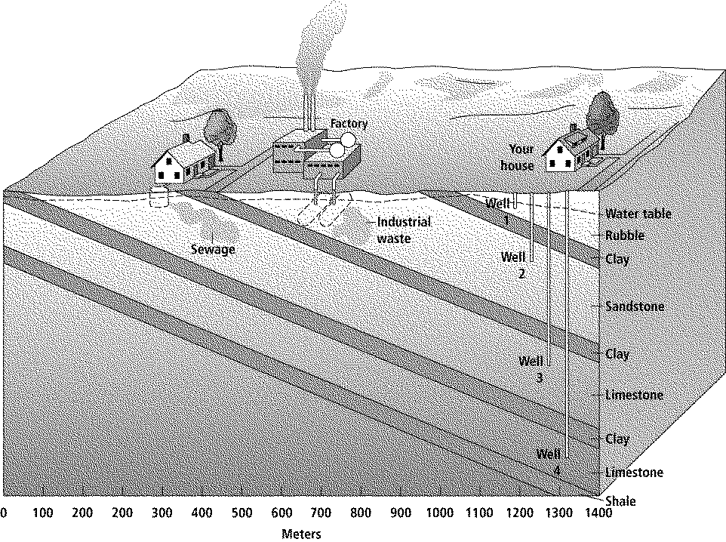

Flow Rate in Meters Per Year
Material | Shale | Clay | Limestone | Sandstone | Rubble
Flow Rate | 0.5 | 0.0 | 100 | 50 | 200

1. Compare and contrast wells 1, 2, and 3. Analyze the potential of each well for a clean, accessible, and maintainable water supply.

2. What is the potential for a clean, accessible, and maintainable water supply from well 4? Could there be a problem with the water?

3. Use the flow rate table to determine when the sewage from the broken septic tank will contaminate the water in well 3.

4. Use the flow rate table to determine when the industrial waste will contaminate the water in well 2. Is it possible that the waste could be made harmless before it reaches the well?

5. Which site has the best potential for your well? Explain your decision.

