Human Effects of the Quality of the Hydrosphere Name:
The Many Ways:
1. - Humans clear land to provide and to accommodate human growth. The removal of trees limits and increases . Eroded soil, in excess, can lower the water quality of nearby streams.
2. - Humans need to feed the global population. These practices maximize harvest by use of pesticides and fertilizers which enter our supply through runoff along with animal waste. Nitrogen compounds in pesticides and fertilizers creates in bodies of water, which removes from the water, creating dead zones.
3. - Humans need to provide and for increasing population. This causes a need for . As impermeable paved surfaces increase the amount of and increases through runoff and enter the water supply.
4. How does the inches of infiltration compare to an area with 85% impervious (impermeable) surface to an area with 0% impervious surface?

5. - Humans harvest materials for use in , industry, and power generation. This results in possible contamination of water supply from mined chemicals or metals. Increased soil and rock debris in river systems can damage and limit species .
6. - Humans produce materials and as a result is demanded by consumers. Industry causes water and air pollutions, which leads to acid rain. Factories are dumping warm waste water used in into a body of water which damages an ecosystem or even kill organisms if the
change is great enough.
7. Power Generation is currently taking place so we can have electricity. Water is used to clean with scrubbers and then discharged, allowing toxins into stream systems which can harm organism and lower water
.
8. Recreation- Humans enjoy being outside, which may result in direct impact on water quality by accidently spilling of oil and gasoline from . Also, trash/human waste/animal waste may contaminate watersheds if not handled appropriately while or .
9. How long does it take for the following household items to decompose?
a. Plastic beverage holder b. Plastic Grocery Bag c. Styrofoam Cup
10. Building - A levee is a usually man made structure built along rivers or oceans, often made of concrete or substrate. Humans build levees to regulate water levels, prevent , and remove water from land so that it may be . Building levees results in redistribution of water and can disrupt in a watershed, limiting freshwater availability to certain ecosystems.
11. Building - A dam is a very expensive barrier designed to control the or to raise the water level of a . Humans build dams for power generation, control
water supply distribution, and to prevent . Building dams can separate organisms of an ecosystem which results in a loss of species diversity. The reservoir side becomes (does not move), effecting water quality. Also, building dams increases collection of sediment on reservoir side, limits flow of sediment downstream, affecting downstream habitats.
12. Carrying Capacity- is the maximum an environment can support. As human population increases, Earth’s carrying capacity does NOT. The same measure of resources are being dispersed amongst a number of people. As a result, of wells is likely to occur, likely causing some wells to become dry. The water table in an aquifer will result in a cone of depression.
13. ________________ _______________________, or the sinking of land, is a problem caused by the excessive withdrawal of groundwater. Over pumping near the ocean can cause the underlying salt water to rise into the wells and contaminate the freshwater aquifer. This process is called _________________________________. Contamination can also occur from a source near the well that may have been avoided if not for ________________________.
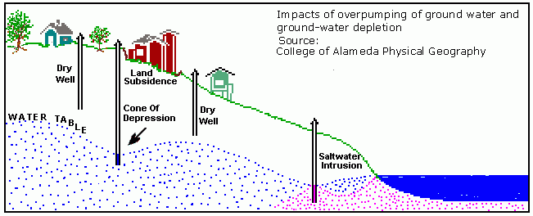

14. Potable water-water that is __________ for humans to drink. As human population ______________________, more waste is going to be generated. Coupling higher amounts of waste with a decrease in water supply increases likelihood of _____________ water quality and water borne ________________________.
15. _________________________ -sewage is treated physically and chemically and then mostly reintroduced to a river system, but some countries and states in the US are recycling water, going from “toilet to tap”.
________________________ -major source of potable water, the ground or river water is treated physically and chemically, result going straight into water supply
16. Each of the ways we affect the hydrosphere discussed thus far mostly incorporates some form of pollution, any contaminant released in the environment that has a impact.

17. In source pollution, the source of pollutants can be traced to a discernable ________________________. Ex: factory dumping waste. The EPA (Environmental Protection Agency) is given authority to issue ________________ to known contributors of point source pollution as means of regulation.
18. Non-point source pollution mostly occurs as a result of runoff, and comes from many different ___________________.
Examples:
  - ____________________________ runoff, can carry any chemical or other contaminant humans dump on land, especially concentrated in urban areas
  - _____________________ and animal _________________ from farmland runoff
  - _____________________________ from poorly managed construction sites, or areas of deforestation
19. The best thing we can do is practice _________________________________, limiting the amount of water use. Water conservation is a _________________________________ practice, can limit energy production, and help to preserve habitats. Making sure we dispose of wastes appropriately can also help limit water _______________________________.
20. What are some ways that you can help?

