Metric System- Guided Notes Name:
Oatmeal Treats-
- What is wrong with the recipe?
- Are measurements important?
METRIC SYSTEM
Developed in 1791 and is currently used almost everywhere in the world, except the US. Our scientists, hospitals, and researchers use this system.
- International System of Units or
- Based on the number
King Henry Doesn’t Usually Drink Chocolate Milk
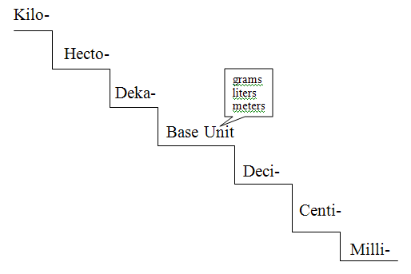
- Prefixes, Numbers and Symbols
- Complete the staircase

Vocabulary
- Length-
  - The standard unit is the
  - Smaller objects are measured using the
  - Even smaller objects are measured using the
  - Long distances=
- Volume-
  - The standard unit is the
  - Small amounts =
  - Large amounts =
  - 1 kL=
  - 3250 L =
  - What instrument is used to find the volume of a liquid?

  - When measuring liquid volume it is important to read the graduated cylinder correctly. Your eye should be level with the top of the liquid and you should read the bottom of the .
  - What would the volume be in the graduated cylinder? a.) b.)
  - Volume of rectangular solids
    - Formula:
    - What is the volume of the box?
- Mass-
  - The standard unit is the
  - The common unit is the
  - Extremely small items are massed using for the unit.
  - 1 g= mg
  - How many mg would = 1 kg?
  - What is the mass on the balance?
  - What is the mass on the triple beam balance?
- Weight-
  - The standard unit=
  - Formula (at sea level)=
  - Gravitational pull would be less on a mountain than at sea level, because
- Time-
  - The standard unit is
  - The common units are
- Temperature-
  - The standard unit is
  - The common units are
- Density-
  - Formula:
  - The density of water is 1.0g/cm³
  - Solve for the density of the gold bars on the lined paper.

