Scientific Method- Guided Notes Name:
The Scientific Method involves a series of steps that are used to a natural occurrence.
Steps of the Scientific Method
1. Problem/Question: Develop a or that can be solved through experimentation.
2. Observation/Research: Make observations and research your topic of interest.
3. Formulate a : Predict a possible answer to the problem or question.
Example:
4. Experiment: Develop and follow a procedure.
- Include a detailed list.
- The outcome must be measurable ( ).
5. Collect and Results: Modify the procedure if needed.
- Confirm the results by .
- Include , , and .
6. Conclusion: Include a statement that or the hypothesis.
Make recommendations for further study and possible improvements to the procedure.
7. Communicate the Results
Baking Bread with the Scientific Method
- Problem/Questions: John watches his grandmother bake bread. He ask his grandmother what makes the bread rise. She explains that yeast a as it feeds on .
John wonders, “Will the amount of sugar used in the recipe affect the size of the bread?”

- Observation/Research: John researches the areas of baking and and tries to come up with a way to test his question. He keeps all of his information on this topic in a . John talks with his teacher and she gives him an Experimental Design Diagram to help him set up his .

- Formulate a Hypothesis: After talking with his teacher and conducting further research, he comes up with a hypothesis. “If more sugar is added, then the bread will rise higher.” The hypothesis is an about the relationship between the and variables.
Independent Variable- The independent, or manipulated variable, is a factor that’s intentionally changed by the experimenter. John is going to use 25g, 50g, 100g, 250g, 500g of sugar in his experiment.
Dependent Variable- The dependent, or responding variable, is the factor that may change as a result of changes made in the independent variable. In this case, it would be the size of the loaf of bread.
anipulated
ndependent variable
-axis (graph)
THE
ependent
esponding
-axis
INGREDIENTS
- Experiment: His teacher helps him come up with a procedure and list of needed materials. She discusses with John how to determine the control group.

Control Group- In a scientific experiment, the control is the group that serves as the standard of The control group may be a “no treatment" or an “experimenter selected” group. The control group is exposed to the same as the experimental group, except the variable being tested is NOT changed.
All experiments should have a control group. Because his grandmother always used 50g of sugar in her recipe, John is going to use that amount in his control group.

Constants- The constants in an experiment are all the that the experimenter attempts to keep the . John’s teacher reminds him to keep all other factors the same so that any observed changes in the bread can be attributed to the in the amount of .
Examples:
Trials- refer to groups that are exposed to the same in an experiment. John is going to test each sugar variable 3 times.
- Collect and Analyze Results: John comes up with a table he can use to record his data. John gets all his materials together and carries out his experiment.

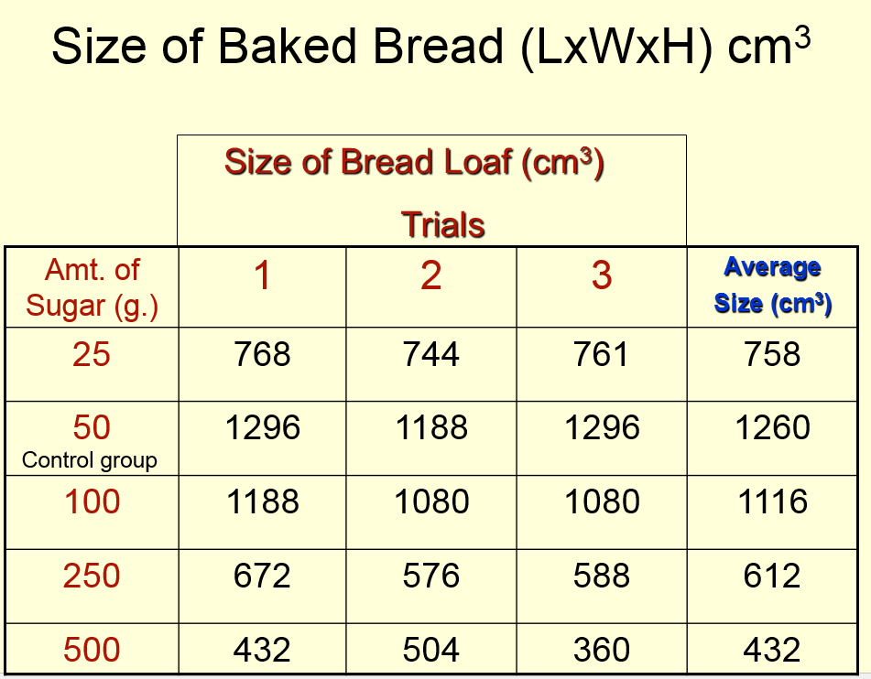

Which of the sugar amounts had the largest average size of bread? grams
John examines his data and notices that his control worked the best in this experiment, but not significantly better than 100g. of sugar.
- Conclusion: John rejects his hypothesis, but decides to re-test using sugar amounts between 50g. and 100g.

After John re-tested his hypothesis, which of the sugar amounts had the largest average size bread?
Grams

- Communicate the Results: John tells his grandmother about his findings and prepares to present his project in Science class.

