isochron map (Figure 1)- used to show the age of the oceanic crust, new sea floor is found at ocean ridges (red in color) while older sea floor is found at deep ocean trenches (blue in color)
paleomagnetism (Figure 2)- study of magnetic record in rocks, iron-bearing minerals in rock become permanently magnetically oriented as rock hardens and points to north, rocks with magnetic orientation pointing south indicate a reversal in earth’s magnetic field
magnetic reversal (Figure 3)- change in Earth’s magnetic field
normal polarity = rocks with magnetic fields pointing north [same orientation as Earth’s present field]
reverse polarity = rocks with magnetic fields pointing south [opposite to present field] found that rocks show many magnetic reversals
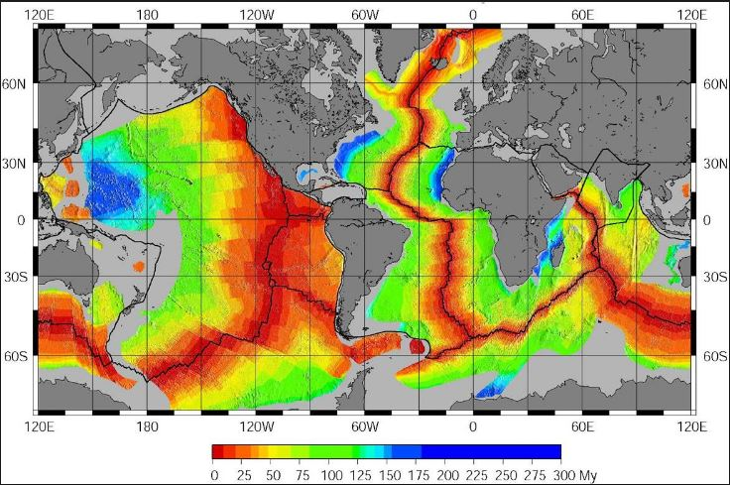
Figure 1

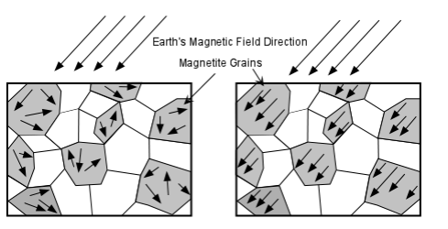
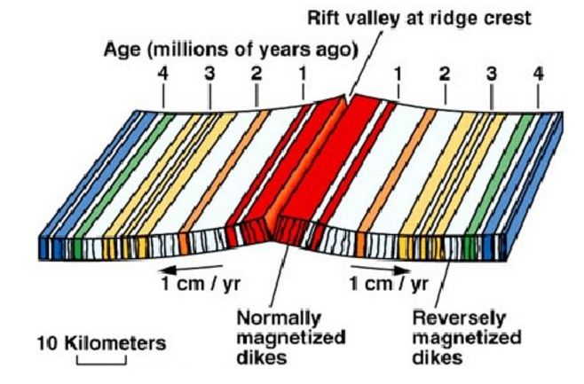
Figure 2 Figure 3

