Oceanography Guided Notes Name:
EEn.2.3.1 Explain how water is an energy agent (currents and heat transfer).
• Explain how the density of ocean water is affected by temperature and how this results in major ocean currents distributing heat away from the equator toward the poles.
• Explain how coastal climates are moderated by water (due to its high specific heat capacity) in comparison to inland climates.
- Modern oceanography investigated ocean currents, water temperature, chemical composition, seafloor sediments, topography, and marine life. Technology included: nets, bottom dredges,
  - Sonar- ( and ) determines ocean depth, uses the return time of an echo and the known velocity of sound in water
  - Satellites- monitor ocean’s surface , , and wave conditions
  - Submersibles- (underwater vessels) investigate the deepest .
- Salinity is the amount of dissolved solids, specifically in the oceans.
- Salinity, temperature, and density within the ocean.
- Increased and decreased result in more water.
- Where do you think these salts come from?
- When the amount of water in the ocean changes, the changes. Anything that increases the amount of water will salinity, or make the water more dilute. Anything that decreases the amount of water will salinity. Increase the water in oceans?
Decrease the amount of water?
- What is density? the formula for density?
- The two main factors that affect density are and
- The higher the , the more the water.
- Why is ocean circulation important?
The currents transport ~ 20% of latitudinal heat from the to the Also, responsible for transporting and in important upwelling areas. These currents influence , climate, and commerce (economy).

- Types of Currents
  - Surface Currents- driven by
  - Deep (Density) Currents- driven by and

- Coriolis Effect- Because of the earth’s , currents are deflected to the
in the Northern Hemisphere and circulate clockwise. Surface currents are deflected to the
in the Southern Hemisphere and circulate counterclockwise.
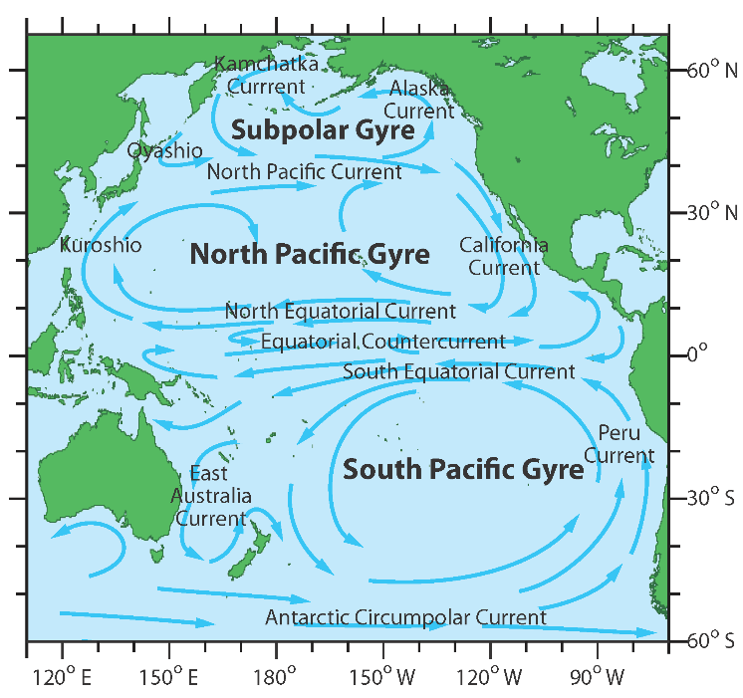
- Gyres- are closed systems of circulating water. The winds blowing from the east are called the
. The winds blowing from the west are called . These opposing wind systems contribute to the formation of gyres.
Explain how gyres influence pollution in the Pacific Ocean.

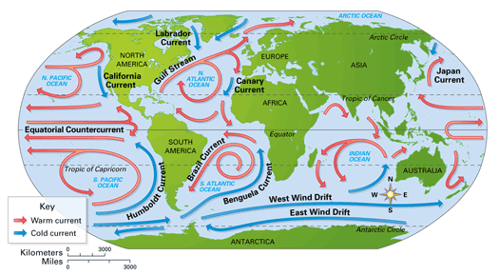
- Global Conveyor Belt- The surface and deep water currents work together to transfer solar from the equator to the poles and helps moderate Earth’s . Deep water currents are colder and higher in , which keeps the currents in deep water. Surface water currents are warmed by the sun and are less because they contain lower levels of salinity. The surface and deep water currents work together to create the “Global Conveyor Belt”

- Upwellings- Winds push surface water offshore, then deeper water moves upward to replace the displaced surface water, deeper water brings (phosphorus and nitrogen) up keeping the ocean ecosystem in balance and to create plankton (microorganisms) blooms.

- Specific Heat- amount of heat required to change a substances by 1`C.
- Not all things heat up at the same rate. It takes different amounts of to heat up different objects. For example, aluminum foil heats up very quickly, however cools very quickly as well.
- How long does it take to boil a pot of water vs. a small room?
- Water has a higher specific heat capacity than air. (Water is more to changing temperature.)
- Land and more rapidly than water. Land also reaches and temperatures than water
- The temperature of the land and water influences the temperature of the air above it
- This explains why areas experience greater temperature variations than
near large bodies of water.
- Climate- pattern of and typical of an area over a long period of time.
- Solar drives in the ocean. Surface currents warm or cool the air above it, influencing the climate of the near the .

- Land/Sea Breezes-
- Another process that occurs as a result of differences in density along coastlines are land and sea breezes.
- Water has a higher specific heat capacity than sand, meaning it takes more to heat 1g of water than it would 1g of sand.
- As a result, water also retains heat energy a lot longer. Specific heats: Salt water: 3.93 J/g Sand: .83 J/g
- SEA BREEZE: during the day, when the land heats up, the air rises the beach will be warmer than the ocean, causing wind to move from the to the , creating a sea breeze. Due to a concentration difference, this causes the wind from the to travel toward the land.
- LAND BREEZE: during the night, ocean is warmer than the sand, causing wind to move from the
to the . The difference in density of these air masses has a very direct effect on the weather experienced along a coastline.

