**Convergent Boundary** (continent-to-continent) Two continental plates collide creating mountain ranges since plates have same density

**Convergent Boundary**   
(ocean-to-continent) Oceanic plate collides with a less dense continental plate and will subduct

**Transform Boundary**  
Place where two plates slip past each other moving in opposite directions

**Divergent Boundary**  
Two plates move apart, or diverge, usually occur at a mid-ocean ridge or   
rift valley

**Convergent Boundary**  
(ocean-to-ocean)   
Two oceanic plates collide and the more dense plate subducts creating volcanic island arcs and a trench

(text)

(picture)

**Examples**

**Plate Boundary**(w/ description of motion)

(pics with arrows)

(pics with crusts)

**Movement of Plates**

**Earth’s Plate Boundaries**

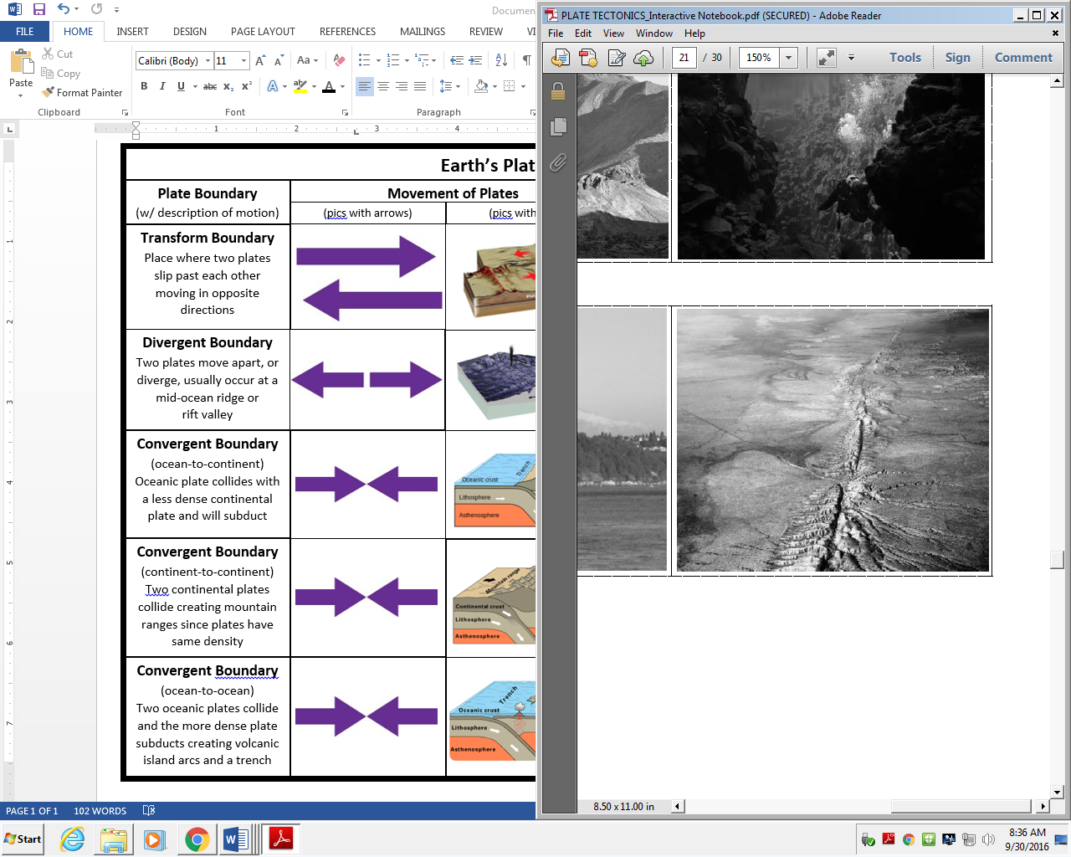

**San Andreas Fault (USA)**

**Alpine Fault   
(New Zealand)**

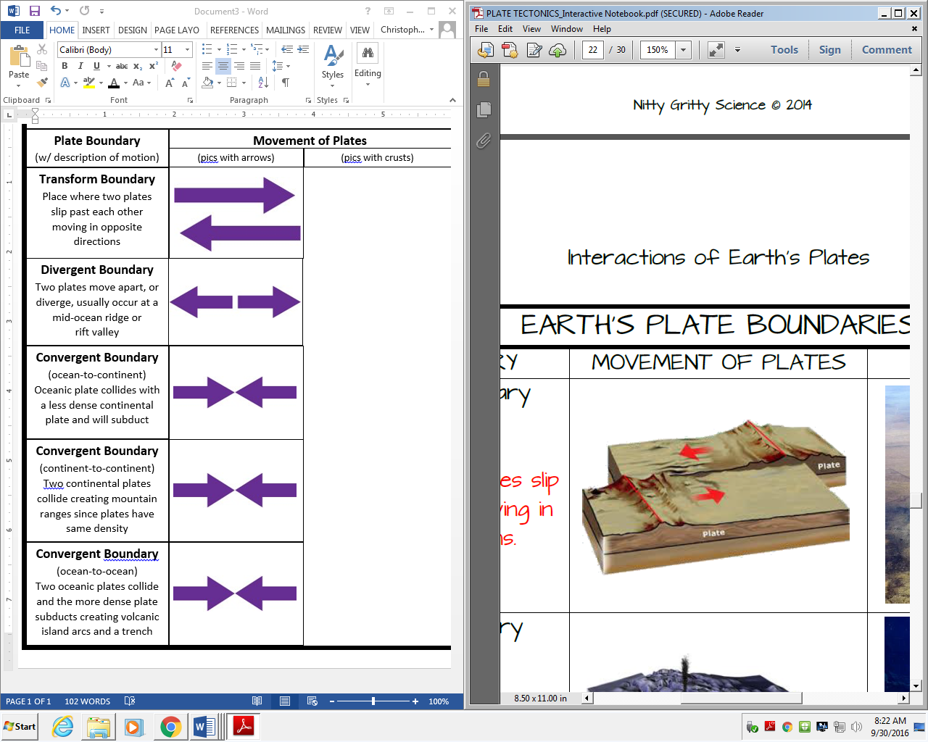

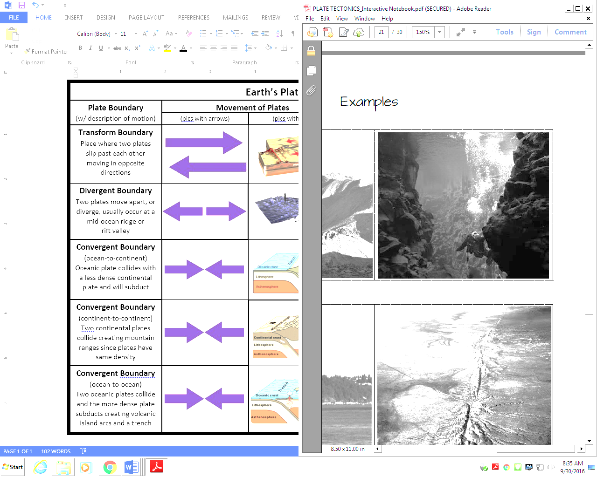

**East African Rift Valley**

**Mid-Atlantic Ridge**

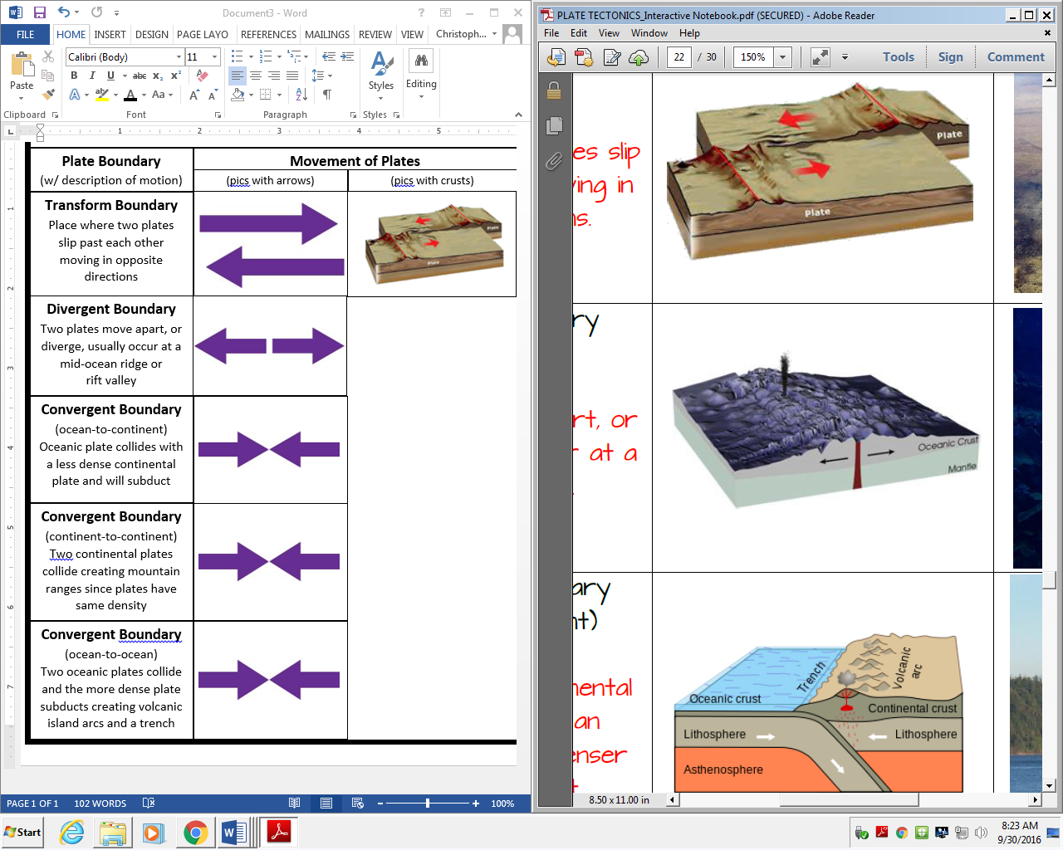

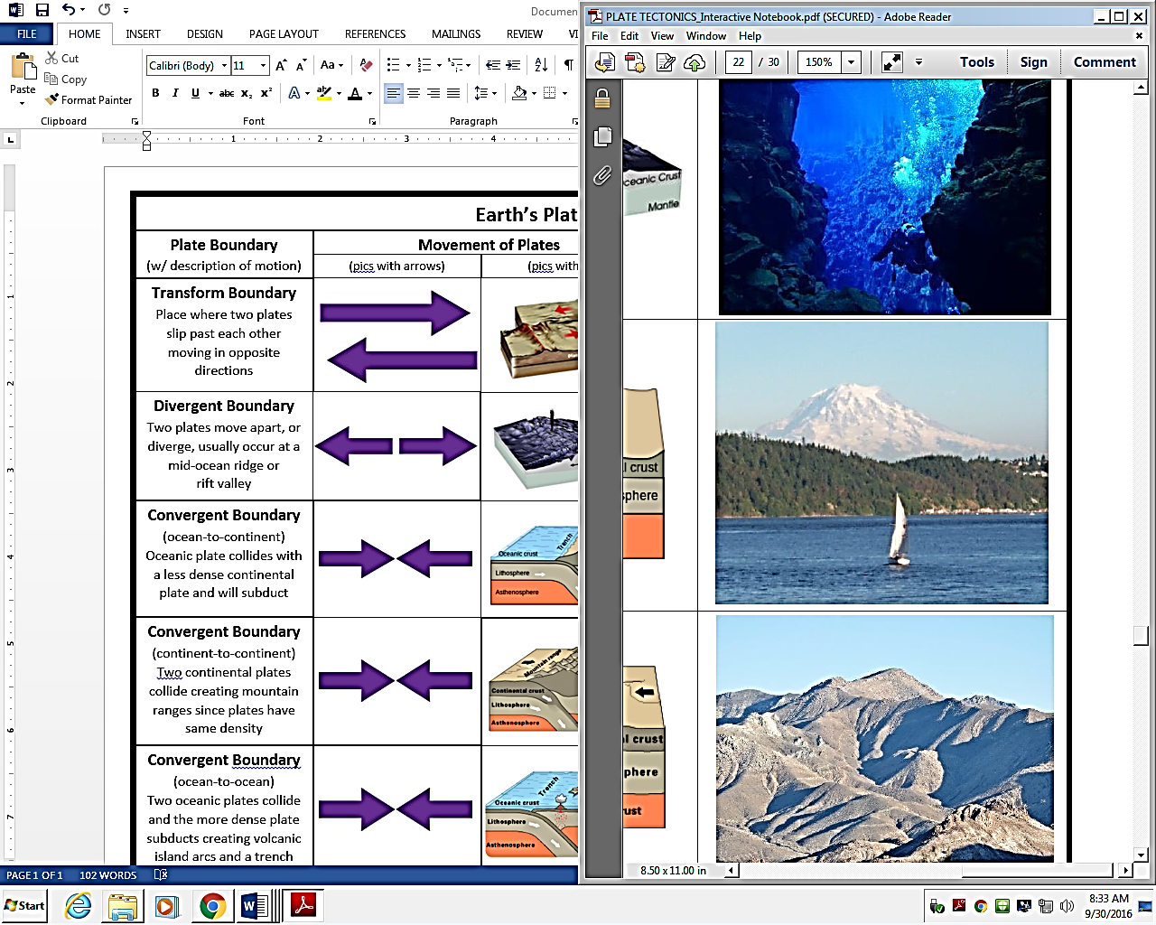

**Andes Mountains (South America)**



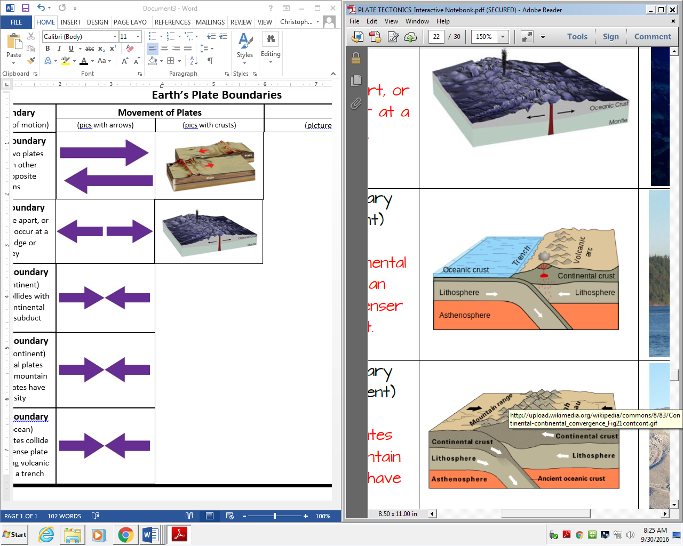



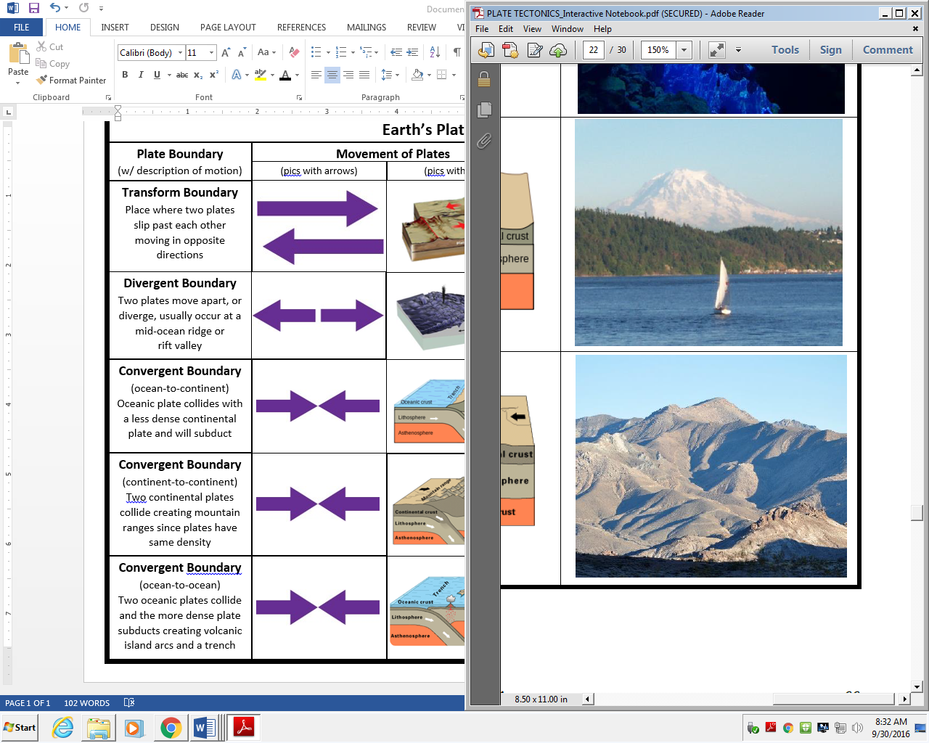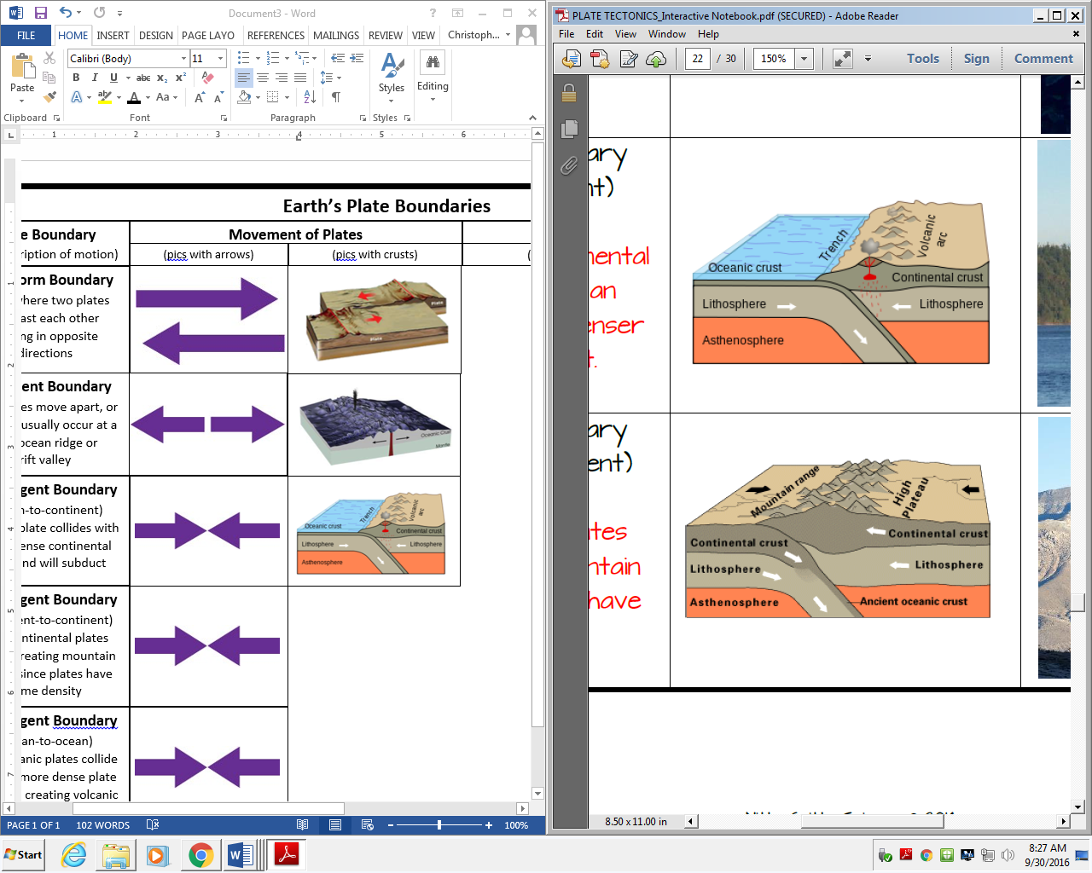

**Himalayan Mountains (Asia)**

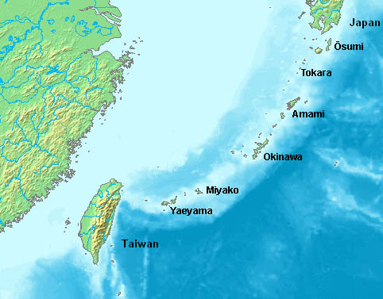

**Aleutian Islands**

**Marianas Trench**

