Review for Earth’s Interior Quiz
- Identify the layers of the Earth
A.)

B.)

C.)

D.)

E.)

- List two examples of evidence geologists used to study Earth’s interior

- Describe 3 differences between oceanic and continental crust
A.)

B.)

C.)

- What is the main difference between the Inner Core and Outer Core?

- What is responsible for the transfer of heat by the mass movement of heated particles into an area of cooler fluid?

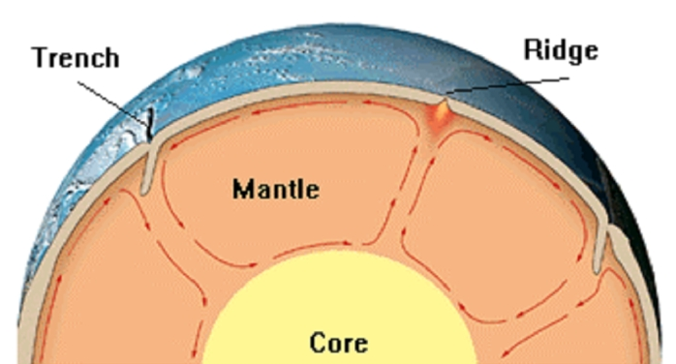
- Label the picture below using the following terms (high density, low density, rising, sinking)

