Earthquakes- Stress and Strain
Strain- a change in the shape of a rock caused by stress
- Elastic strain-

- Plastic/Ductile strain-

Stress- Strain Curve- there is a distinct relationship between stress and strain that can be plotted.
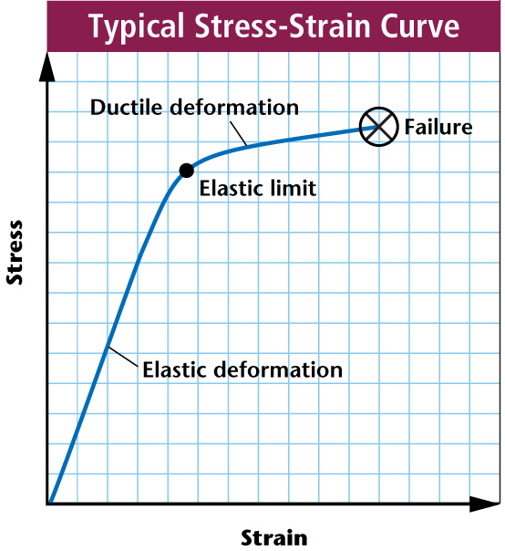
- Low produce the straight segment,
which represents the strain of a
material.
- If the elastic strain is reduced to ,
the deformation .
Ductile Deformation
- When stress exceeds a certain value (elastic limit),
a material undergoes deformation,
shown by the curved segment of the graph.
- This type of strain produces permanent deformation,
which means that the material stays
even if the stress is reduced to .
- When stress exceeds the strength of a material, the material breaks, or , as designated by the X on the graph.
- Most rocks, though on the surface, become ductile at the higher present at greater .
Elastic Rebound Theory- explains how energy is stored in rocks
- Rocks bend until the strength of the rock is .
- Rupture occurs and the rocks quickly rebound to an shape
- Energy is in waves that radiate outward from the .

