Life on Earth
Name:
The Sun supports life on earth by providing the required for survival. The Sun warms our planet by heating the surface, the oceans and the atmosphere. The energy from the Sun travels to the Earth through , the transfer of thermal energy by electromagnetic waves. The Sun allows plants to grow via which in turn absorbs and creates .
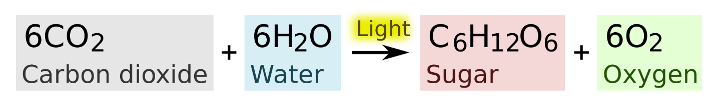

The Sun’s Energy
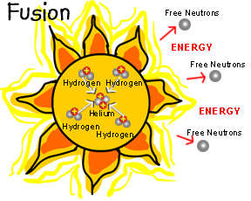
You might be wondering where all the energy that causes solar activity and light comes from. Fusion occurs in the core of the Sun, where the and are extremely high. is the combination of lightweight, atomic nuclei into heavier nuclei. Fission is the opposite, which is the splitting of heavy atomic nuclei into smaller, lighter nuclei, like uranium into lead. Deep in the sun's core, nuclear fusion reactions convert to
, which generates energy. During fusion, hydrogen atoms are together to create a helium and release a tremendous amount of
.
NUCLEAR
Solar Flares
A solar flare is a sudden and intense variation in brightness from a energy build up. The radiation from past solar flares are responsible for disrupting , electronic and devices failure, and causing telephone wires to burn into flames.
Solar Winds
Plasma flows outward from the corona at high speeds in the forms of
. This wind of charged particles, called , flows towards all of the planets. The charged particles are deflected by Earth’s and are trapped in two huge rings located at each of the Earth’s . The high-energy particles in these belts collide with gases in the Earth’s and cause the gases to give off . This phenomenon of a light show, called the
, can be seen from Earth or from space.
Layers of the Sun
There are 3 outer layers of the sun. The first layer, the , is a star’s outer shell in which light is radiated. The next two layers make up the Sun’s outer most atmosphere. The , “sphere of color”, is above the photosphere. The , “crown”, of light is what give the Sun its defining physical appearance. are arcs of gas that are anchored in the photosphere layer of the sun and extend through the corona.
Sunspots
These are small, dark spots seen on the surface of the Sun. Sunspots are caused by strong
on the Sun’s surface. The magnetic fields are caused by the Sun’s . The rotation of the Sun causes one sunspot to have a north magnetic polarity and another to have a south magnetic polarity.
Draw and label the following on the lined paper using the
The Sun Guided Notes PowerPoint:
Sun, Earth, solar winds, magnetic field, aurora ovals, solar flare, prominence, sunspot, corona, chromosphere, photosphere, and nuclear fusion

