Hierarchy of the Universe
Name:

Solar System
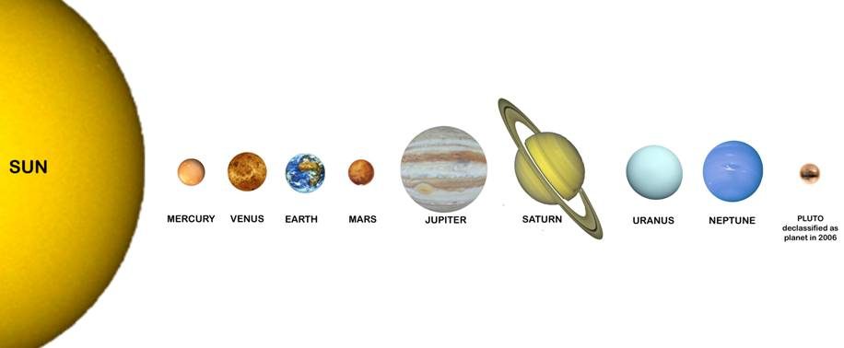

My Very Excited Mother Just Served Us Noodles

GEO-centric=

HELIO-centric=
- 1543 Polish scientist Nicolaus Copernicus suggested Sun was center of solar system
- First time a sun-centered or “heliocentric” model was proposed
- In a heliocentric model, the inner planets move faster in their orbits than the outer planets do; as Earth bypasses a slower moving outer planet it appears the outer planet temporarily moves backward in the sky

The Big Bang Theory- states that the universe began as a point and has been ever since. There are many misconceptions about the Big Bang Theory.
Misconceptions:
- The Big Bang was an .
  - There was NO .
  - Reality: space expands
    - When there is more space between , they “move” away from each other like the “dots on an expanding balloon”
- The Big Bang Theory is an explanation for how the universe was .
  - Reality: explains how the universe first started but leaves many unanswered questions.
    - Time, Space, and Matter were created in the Big Bang
- There is NOT for the Big Bang Theory
  - Reality:
    - Shift
    - Cosmic Background

The Doppler Effect- Red Shift vs. Blue Shift (write an explanation for the images below)
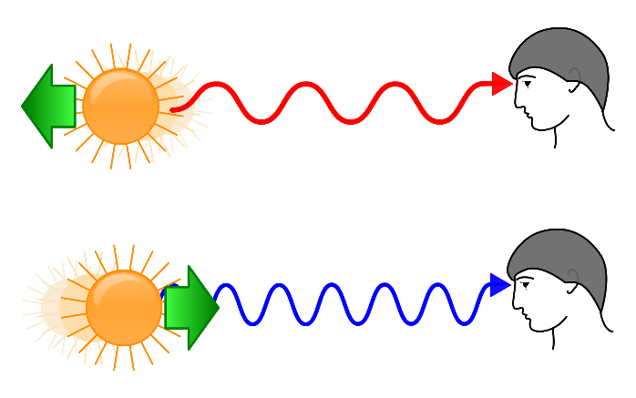

Kepler’s First Law
Kepler’s 1st Law: All planetary orbits are ______________________ in shape.
A planet is in orbit as shown below. Draw 2 possible locations for a Sun. Label the Earth and Sun

Kepler’s 2nd Law- a line joining a planet to its sun sweeps out equal areas in equal times as the planets travel along its orbit.
Use the diagram below to explain how and why a planet’s speed changes as it travels around its sun. Think about when a planet travels faster/slower in its orbit.

